**Jim**

Always 怀念 changez

But evidently, he will never understand Changez

Changez 有更多余的情感

Jim就是一个一心工作的美国人

“I saw myself”

“Am I wrong”

“He was never ever the me”

We can see the cultural difference between Changez and Jim in the way of thinking. changez focuses more on cultural identity,…

While Jim only thinks of his profit and money as the American motto “Make as much money as possible and as far as you can”

Jim, Changez’ boss reveals his ideas: Changez is like a shark. He is determinate and “*never stops swimming*”, he is constantly working to reach the top. Both of them have similar backgrounds, different from the others, that’s why they are “*not mart of this world*”.

Jim tries to comfort him saying that the world always changes and evolves. *”Power comes from being change”.* Jim suggests him to not think about personal problems because everything is going to be all right, the important is to continue to gain money: “*Focus on the fundamentals*” But Changez doesn’t agree completely with that sentence and idea, that’s one of the reasons why he is Reluctant.

It is also true that his sense of pride and patriotism starts to grow up. He gets emotional involved when speaking about Pakistan. America is judging his country and he is taking its defenses.

Jim notices Changez’ strange and anxious behavior and gives him the change to go to Chile not only because the young Pakistani is a great worker but because he hopes that, in that way, Changez will not think about his problems with Erica and Pakistan.

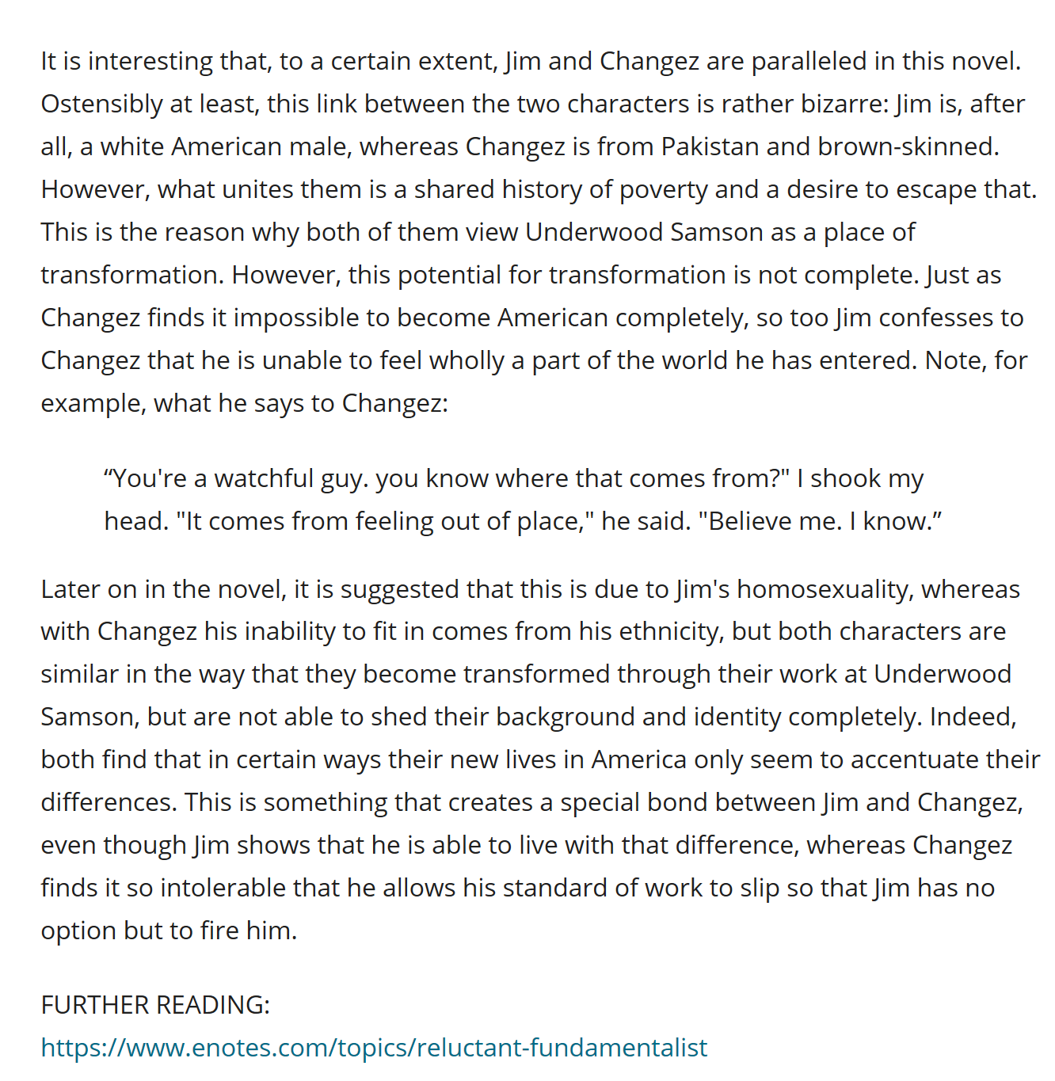

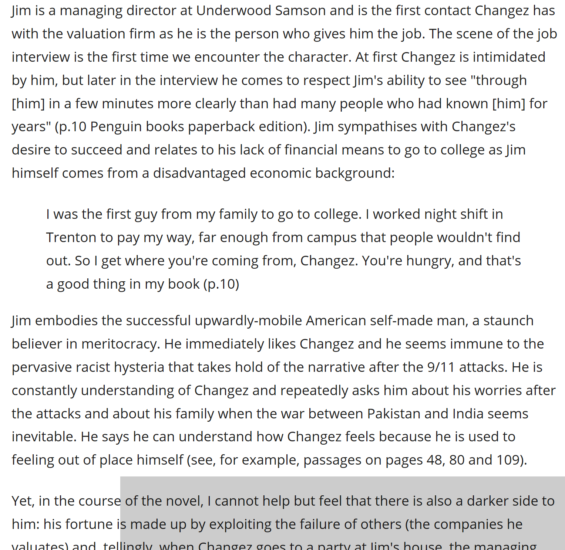

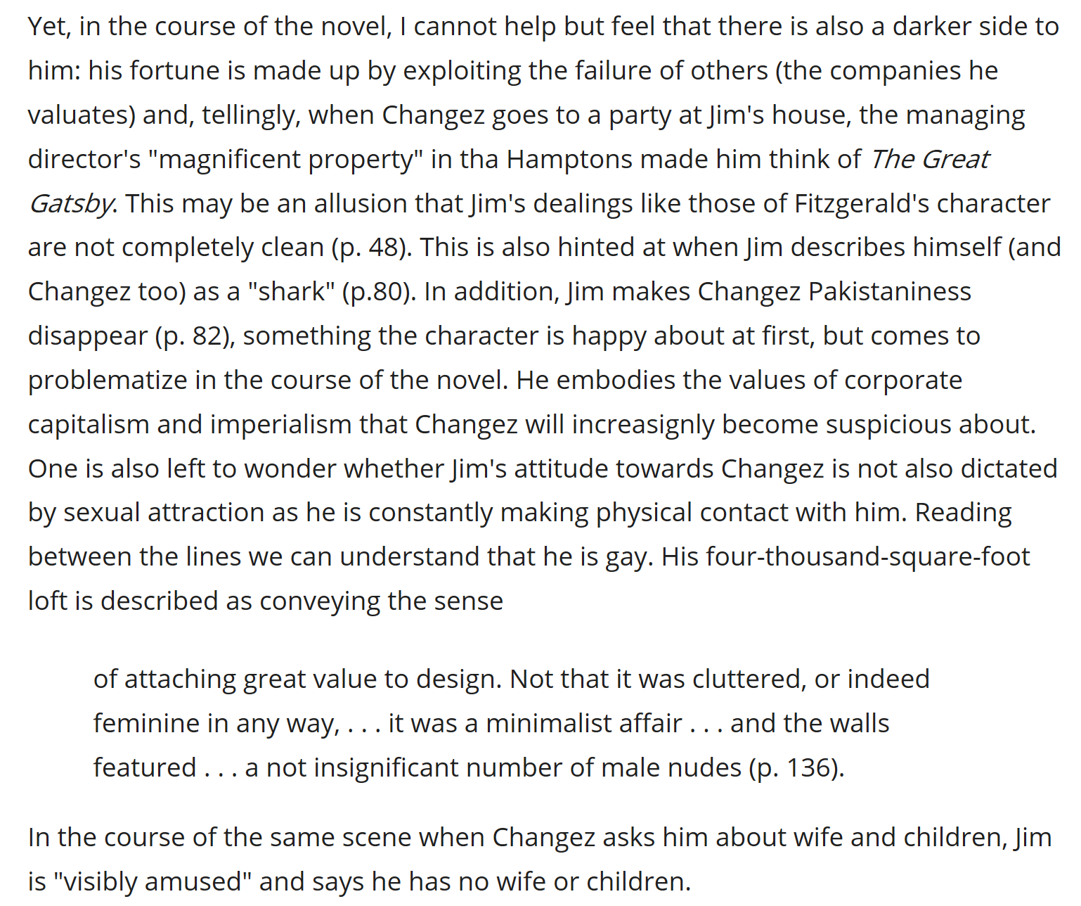

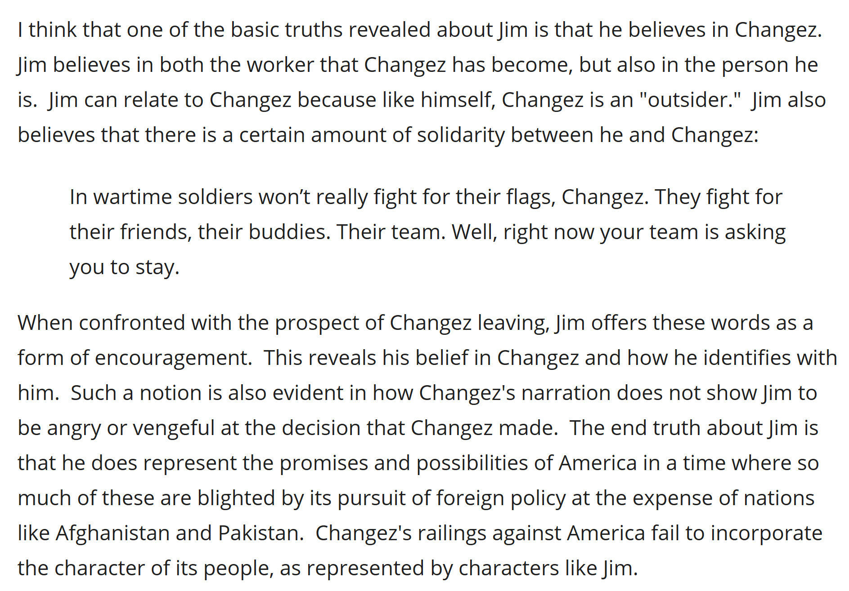

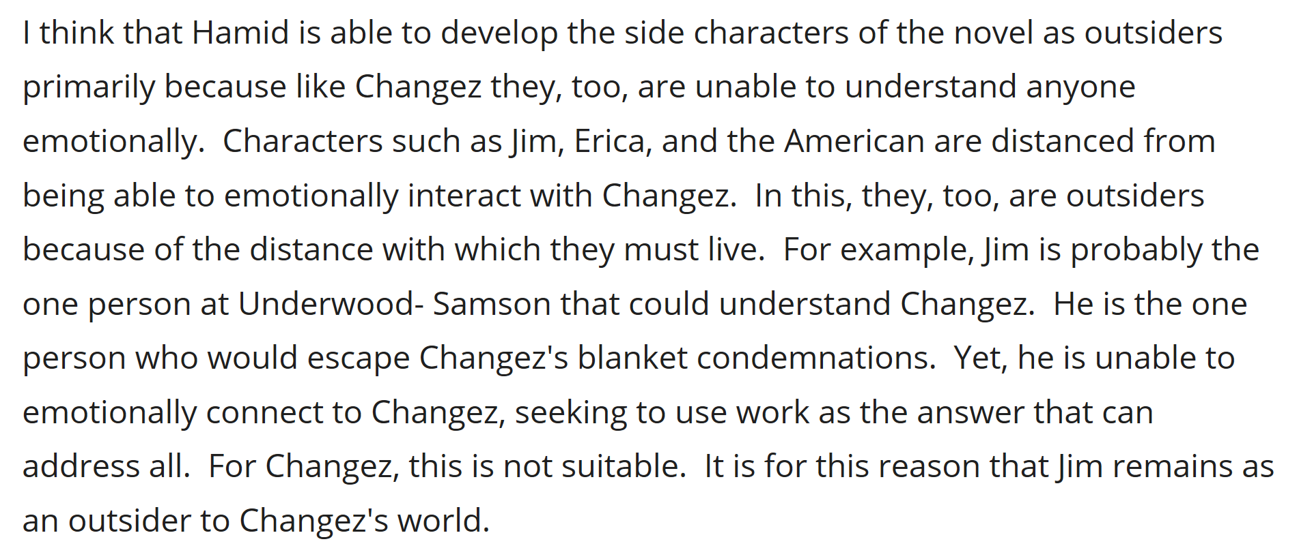

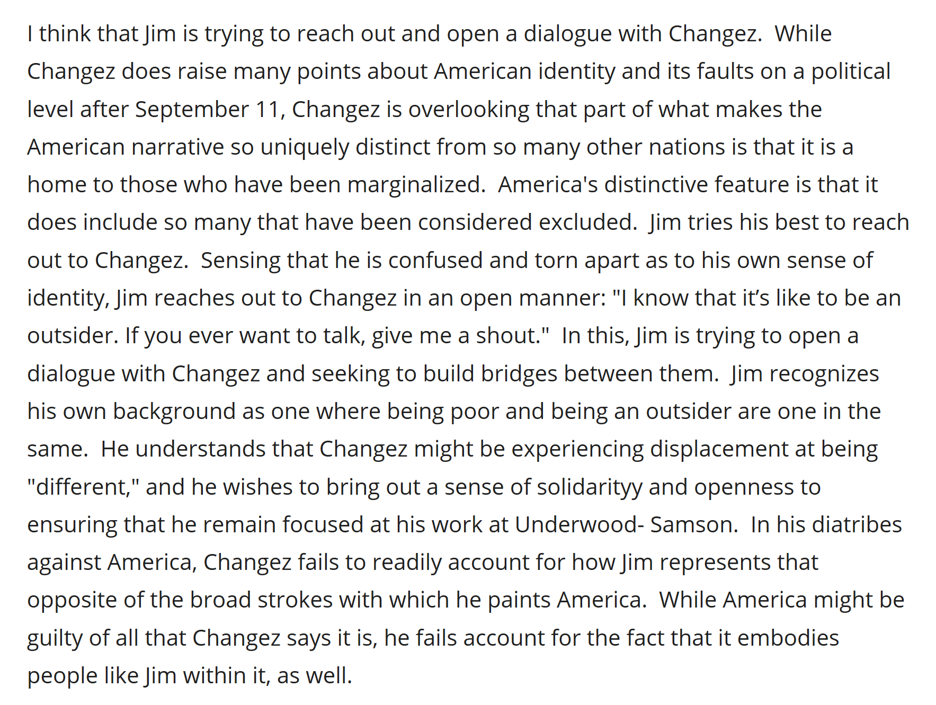

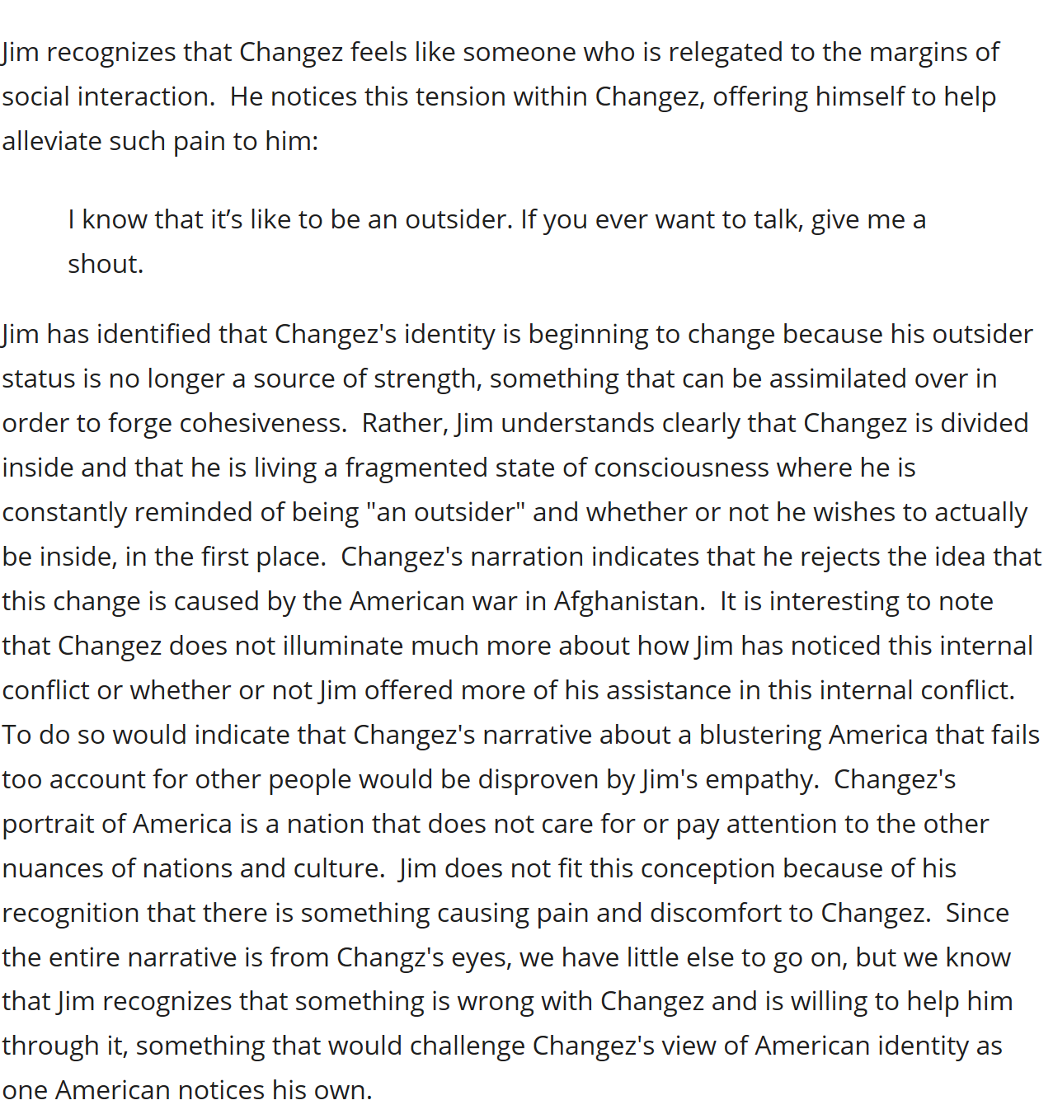

**The nurse**

My name is Kathy. I have been in this health center for 20 years now.

She reminded me of a patient 14 years ago. Her name is Erica.

Meanwhile he goes to visit Erica in a clinic. Changez represent for Erica the most real thing in the world and something that makes her loose her balance. She is not clear and have a contorted vision of the world.

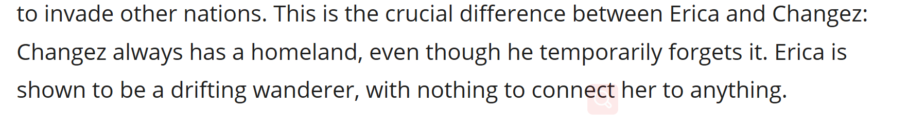

**Wainwright**



